# Chapter 1

**Optimizing Cold Start Latency in Serverless Computing**

*N Yaswanth, R Rohan Chandra*

**Learning Outcomes**

After reading this chapter, the reader will be able to:

* Understand serverless computing and the issue of cold start latency.
* Identify key methods to reduce cold starts, like container pooling and pre-warming.
* Recognize the use of ML and XAI for dynamic resource optimization in serverless platforms.
* Analyze the effectiveness of predictive models, such as deep neural net- works and LSTMs, in managing serverless function invocations.
* Evaluate the proposed model’s improvements in response time, cold start delay, and resource efficiency.

1

2*CHAPTER 1. OPTIMIZING COLD START LATENCY IN SERVERLESS COMPUTING*

## Introduction

### Background

The rise of digital technologies in the mid-twentieth century marked the beginning of an era where traditional business models were reshaped by technological advance- ments. As industries increasingly relied on digital and network-based technologies, the need for scalable infrastructure solutions became evident. This shift paved the way for *cloud computing*, which introduced scalable, on-demand access to shared computing resources. Cloud computing models, including Infrastructure as a Service (IaaS), Platform as a Service (PaaS), and Software as a Service (SaaS) [11], offered businesses an alternative to managing extensive hardware setups, thereby reducing operational costs and complexity. These models allowed enterprises to leverage vir- tualized infrastructure, managed platforms, and hosted applications to streamline operations, support growth, and enhance flexibility.

In 2014, *Amazon Web Services (AWS)* introduced the concept of *serverless com- puting* through AWS Lambda. This new cloud computing paradigm shifted the focus from managing infrastructure to focusing solely on code. Serverless comput-

ing abstracts infrastructure management completely, enabling developers to deploy and execute functions without the need to provision or manage servers manually. Platforms like AWS Lambda, Google Cloud Functions, and Microsoft Azure Func- tions automatically allocate resources in response to user demands, simplifying the development process and improving scalability [13]. This design has made serverless computing a preferred choice for applications with fluctuating workloads, such as event-driven applications and microservices.

Despite its advantages, serverless computing introduced unique challenges. One of the most critical is the *cold start* problem, which occurs when a serverless function is invoked after a period of inactivity. During a cold start, the serverless platform must allocate and initialize resources, such as containers or virtual environments, before executing the function. This initialization process can lead to delays, particularly in latency-sensitive applications, as the function cannot start processing until all resources are ready. Cold starts are especially problematic for real-time applications where responsiveness is crucial, as these delays can degrade user experience and reduce the effectiveness of time-sensitive operations [13].

### Motivation

While serverless computing offers notable benefits in terms of cost savings, scalability, and developer productivity, the cold start problem remains a significant performance

* 1. *INTRODUCTION* 3

bottleneck. Cold starts introduce latency that can range from a few milliseconds to several seconds, depending on factors such as function size, memory allocation, and platform-specific configuration [12]. This latency can pose a major challenge for applications requiring rapid responses, including healthcare monitoring systems that depend on real-time data, financial transaction systems with stringent latency requirements, and Internet of Things (IoT) applications where delayed responses can compromise system integrity.

The cold start issue arises primarily because serverless functions are designed to be *stateless*; resources are released after each execution to reduce costs, meaning that a new container must be initialized for subsequent invocations after a period of inactivity. Existing approaches, such as *container pre-warming*, involve keeping functions in a partially initialized state for a set period after execution, which can help reduce cold start delays [6]. However, pre-warming is often inefficient, as it can lead to wasted resources when containers remain idle during off-peak periods. This strategy may also increase operational costs, as platforms may continue to reserve resources that are not actively utilized.

To overcome these limitations, there is a pressing need for more *adaptive solu- tions* that can dynamically adjust resource allocation based on real-time function invocation patterns. Ideally, these solutions should optimize resource usage without compromising performance, allowing serverless platforms to handle unpredictable workloads efficiently [12]. Such adaptive solutions would not only enhance response times but also reduce operational costs, providing a more robust serverless computing environment for high-demand applications.

### Objectives

This chapter introduces a novel framework that employs Machine Learning (ML) and Explainable AI (XAI) techniques to address the cold start problem in serverless com- puting environments. By integrating predictive models such as deep neural networks and Long Short-Term Memory (LSTM) networks, this framework aims to optimize the pre-warming of containers based on function invocation patterns [1]. This adap- tive approach allows the system to anticipate periods of activity and proactively manage resources, reducing cold start occurrences and delays [14].

The specific objectives of this chapter are:

* + - * **To propose an adaptive machine learning approach** that uses XAI tech- niques to enhance transparency and interpretability in serverless resource man- agement. XAI helps stakeholders understand and trust the system’s resource

4*CHAPTER 1. OPTIMIZING COLD START LATENCY IN SERVERLESS COMPUTING*

allocation decisions, especially in high-stakes applications where reliability is crucial [3].

* + - * + **To develop methods for optimizing the idle container duration**, min- imizing resource waste while ensuring readiness for incoming requests. By calculating the optimal idle-container window based on historical invocation patterns, the framework can keep containers warm only when needed, thus achieving a balance between performance and cost [14].
        + **To evaluate the effectiveness of the proposed model** in comparison with traditional strategies such as static pre-warming. Through experimental anal- ysis across different serverless platforms, this study demonstrates the model’s ability to reduce cold start latency, enhance response times, and achieve higher resource efficiency [1](#_bookmark3), [3].

By achieving these objectives, this chapter aims to provide insights into how AI-driven solutions can enhance serverless computing performance, particularly in latency-sensitive and high-demand environments. This framework not only con- tributes to the efficiency of serverless platforms but also addresses the need for trans- parent and cost-effective resource management strategies that can adapt to evolving application requirements [3].

## Cloud Computing Overview

### Service Models

Cloud computing provides various service models that offer different levels of control, flexibility, and abstraction [11]. These models allow businesses and developers to choose the level of management and customization needed for their applications. The primary cloud service models include:

1. **Infrastructure as a Service (IaaS):** IaaS is the most fundamental cloud ser- vice model, providing virtualized computing resources over the internet [13]. With IaaS, organizations can provision and manage virtual machines, storage, and networking resources, giving them full control over the underlying infras- tructure. This model is highly customizable, allowing businesses to configure resources according to their specific requirements. IaaS is particularly useful for organizations that need to manage complex applications or require extensive control over their infrastructure. Examples of IaaS providers include Amazon
   1. *CLOUD COMPUTING OVERVIEW* 5

Web Services (AWS), Microsoft Azure, and Google Cloud Platform (GCP), which allow users to scale resources up or down based on demand and avoid the costs associated with purchasing physical hardware.

1. **Platform as a Service (PaaS):** PaaS abstracts much of the underlying in- frastructure, providing a managed environment for application development and deployment [13]. In a PaaS environment, developers focus on writing code and building application functionality while the platform handles infrastructure management tasks, such as resource allocation, scaling, and load balancing. This model allows developers to concentrate on application logic and features without needing to worry about the underlying hardware or software config- urations. PaaS environments typically include tools for development, testing, and deployment, making it easier for developers to bring applications to market faster. Examples of PaaS include Google App Engine, Microsoft Azure App Services, and Heroku, each offering built-in support for databases, developer tools, and web frameworks [15].
2. **Software as a Service (SaaS):** SaaS provides fully managed applications that are hosted in the cloud and accessible to users over the internet [11]. With SaaS, users do not manage or control the underlying infrastructure or application code; instead, they access the software through a web browser or application interface [13]. This model simplifies software use for end-users and eliminates the need for software installation, maintenance, and updates. SaaS is ideal for organizations looking for convenience and ease of use, as it requires minimal technical setup and is often billed on a subscription basis. Examples of SaaS applications include Salesforce, Google Workspace, and Microsoft Office 365, which provide accessible tools for productivity, collaboration, and customer relationship management without requiring user-side maintenance.

### Deployment Models

Cloud deployment models determine how cloud resources are made available to users and define access control, security, and collaboration capabilities. The main cloud deployment models include:

1. **Public Cloud:** In a public cloud model [11], cloud resources are owned and operated by third-party cloud providers and are made available to multiple

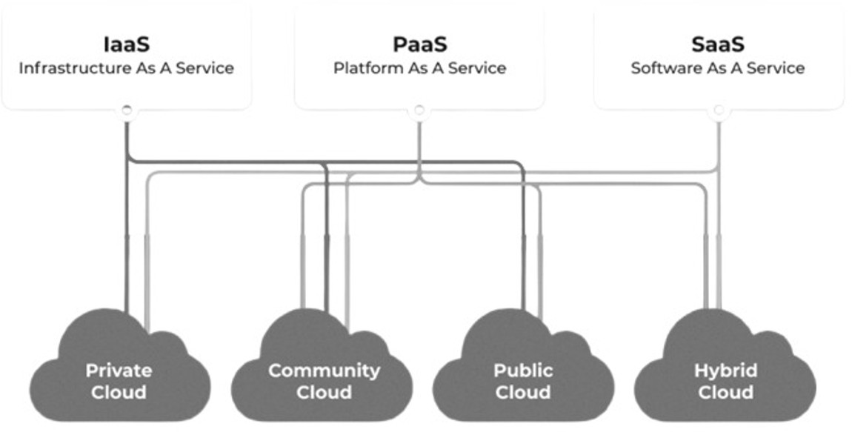

Figure 1.1: Cloud Service Models

customers over the internet. This model offers cost-effective access to high- performance computing, storage, and applications without the need for organi- zations to invest in their own hardware. Public clouds operate on a pay-as-you- go basis, making them attractive to businesses seeking to avoid upfront capital expenditures. Public clouds are highly scalable and flexible, with examples including Amazon Web Services (AWS), Microsoft Azure, and Google Cloud Platform (GCP). However, as public clouds are shared environments, they may offer less customization and control compared to private cloud options.

1. **Private Cloud:** A private cloud [11] is a cloud environment dedicated to a single organization, providing greater control, privacy, and security. Private clouds can be hosted on-premises or managed by a third-party provider, and they are tailored to meet the organization’s specific requirements. This model is ideal for organizations with strict regulatory or security needs, such as finan- cial institutions or government agencies. Private clouds allow organizations to maintain control over their data and customize their infrastructure. While they offer increased security and compliance capabilities, private clouds typi- cally involve higher costs and require more resources to manage than public cloud environments.
2. **Community Cloud:** Also known as an organizational or industry cloud, a community cloud model is designed for use by multiple organizations that share common goals, policies, or compliance requirements [11]. This model allows organizations within a specific industry—such as healthcare, education, or government—to collaborate and share resources within a secure environ-

ment. Community clouds are typically hosted and managed by a third-party provider or jointly managed by the participating organizations. They provide the benefit of a shared infrastructure while maintaining specific access controls and compliance standards required by the community.

1. **Hybrid Cloud:** The hybrid cloud model [11] combines public and private cloud environments, allowing data and applications to be shared between them. This model provides the flexibility to run general workloads in the public cloud while keeping sensitive data and critical applications in the private cloud, bal- ancing security with scalability. Hybrid clouds enable organizations to leverage the best aspects of both public and private clouds, supporting seamless inte- gration and data transfer between environments. For instance, organizations might use the public cloud for high-volume, low-security tasks while keeping sensitive workloads in their private cloud. Hybrid clouds are particularly valu- able for organizations that need to optimize performance, cost, and security, as they can dynamically manage workloads across different environments.

This overview of cloud computing models highlights the different levels of service and deployment options available, enabling organizations to choose solutions that align with their business needs, security requirements, and budget constraints.

## Serverless Computing and Cold Start Problem

### Serverless Architecture

Serverless computing represents a transformative shift in cloud computing paradigms, enabling developers to focus primarily on writing application code rather than man- aging the underlying infrastructure [5,](#_bookmark7) [8]. This model leverages the concept of *Func- tion as a Service (FaaS)*, where applications are composed of discrete functions that execute in response to specific events or triggers. Serverless platforms, such as AWS Lambda, Azure Functions, and Google Cloud Functions, autonomously handle the complexities of infrastructure management, including resource provisioning, scaling, and maintenance, allowing developers to concentrate on application logic.

**Characteristics of Serverless Computing** include:

* + - * **Small and Temporary Functions:** Functions are inherently ephemeral, exe- cuting only when triggered by specific events and relinquishing resources imme- diately after completion. This statelessness contrasts with traditional comput- ing models, where persistent applications may occupy resources continuously, regardless of demand.

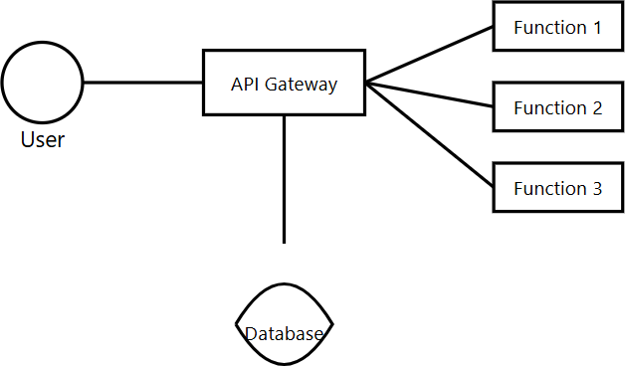

Figure 1.2: serverless computing

* + - * + **Stateless Execution:** Each function operates independently and retains no state between invocations. This stateless nature simplifies scalability, as func- tions can be executed concurrently without concerns about shared state or data consistency.
        + **Event-Driven Architecture:** Functions are invoked in response to events, which can include a variety of triggers such as HTTP requests, changes in database records, or messages from IoT devices. This event-driven approach allows applications to respond dynamically to real-time data and user interac- tions.

**Execution Process:** Serverless functions run within lightweight, isolated con- tainers, which provide a secure environment for execution. When a function is in- voked, a new container is created (or a warm container is reused), and concurrent invocations are handled in separate containers to enhance performance and isola- tion [8]. The execution process typically unfolds as follows:

1. **Container Initialization:** Upon invocation, the serverless platform config- ures the environment by setting up environment variables, establishing connec- tions to necessary services (like databases), and handling user authentication. This initialization step is crucial for preparing the function to execute success- fully.
2. **Resource Allocation:** The platform dynamically allocates resources, includ- ing memory and CPU, based on the function’s requirements. This elasticity enables optimal performance, as resources can be scaled up or down depending on demand.
3. **Function Execution:** The serverless function processes the incoming request, performing the necessary computations and operations. This execution can involve accessing external APIs, querying databases, or executing business logic as defined by the developer.
4. **Result Return:** After processing, the function returns the result to the caller and logs execution details, such as the duration, memory usage, and any errors encountered. These logs are valuable for monitoring and optimizing function performance.

### Cold Start Issue in Serverless Computing

One of the most significant challenges facing serverless computing is the *cold start* problem [12]. This issue arises when a serverless function is invoked after a period of inactivity, necessitating the creation and initialization of a new container. Cold starts can introduce latency that varies based on several factors, including the function’s complexity, the presence of external dependencies (like libraries or services), and the cloud environment’s operational conditions.

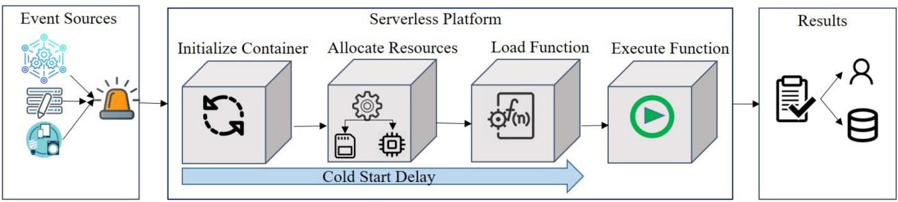

Figure 1.3: Cold start delay [12]

Cold starts can adversely affect user experience, particularly for latency-sensitive applications, such as real-time data processing or IoT systems. To mitigate the im- pact of cold starts, some platforms employ strategies to keep functions in a "warm state" after execution, preserving runtime environments to reduce initialization times.

However, this approach can lead to resource waste, especially when functions remain idle for extended periods.

In summary, addressing cold start delays is critical for optimizing serverless ap- plications, improving resource efficiency, and ensuring a reliable user experience in high-demand environments.

## Related Works

### Traditional Cold Start Mitigation Techniques

To address the challenges posed by cold starts in serverless computing, various tra- ditional techniques have been developed. A common approach is *container pooling*, where a pool of pre-warmed containers is maintained to reduce initialization time [9]. In this strategy, platforms like AWS Lambda, Google Cloud Functions, and Microsoft Azure aim to reuse halted containers for subsequent requests within a designated idle- container time window. By retaining these containers in a ready state, the frequency of cold starts is significantly reduced, leading to improved response times for users and a more efficient allocation of resources [7].

Another prevalent technique is *pre-warming*, which involves keeping containers in a “warm state” for a specified duration after execution [6]. This approach ensures that runtime environments and loaded libraries remain intact, facilitating faster sub- sequent invocations. While this method effectively mitigates cold start delays, it can lead to unnecessary memory consumption if containers remain idle for extended periods. AWS Lambda’s provisioned concurrency feature exemplifies this strategy, allowing developers to specify the number of pre-warmed containers that should be maintained for upcoming requests. This feature helps to balance the trade-off between minimizing cold start occurrences and optimizing resource usage, thus pro- viding a more tailored serverless experience.

Additionally, techniques such as *prebaking* and *warm template queue containers*

have emerged as effective strategies for cold start mitigation. Prebaking involves cap- turing container snapshots before function execution, which can significantly accel- erate the startup time during subsequent invocations. This technique is particularly beneficial in scenarios where functions have large dependencies or complex initial- ization processes. On the other hand, warm template queue containers—used in models like the Warm Load Execution Context (WLEC)—maintain copies of warm containers in a queue, allowing for rapid function execution upon demand. This en- sures that when a function is called, the necessary environment is already prepared, further reducing cold start latencies [10].

*1.4. RELATED WORKS* 11

|  |  |  |  |
| --- | --- | --- | --- |
| **Strategy** | **Approach** | **Resource Consumption** | **Adaptability** |
| ACPS | Adaptive container pool scalability | Moderate | Low |
| Prebaking | Container snapshots for pre-launching | Low | Moderate |
| WLEC | Warm template queue containers | High | Low |
| Provisioned Concurrency | Configurable warm containers | High | Low |
| SAND | Application-level separation | Moderate | Moderate |
| SOCK | Performance bottlenecks in containers | Moderate | Low |
| Pagurus | Resource sharing among warm containers | Moderate | High |
| HotC | Pool of warm containers with Markov model | Moderate | High |
| Q-learning | Dynamic scaling based on patterns | Moderate | High |
| Hybrid Histogram Policy | Optimal idle-container window | Low | High |
| LSTM-based models | Predictive resource management | Low | High |
| Deep Reinforcement Learning | Continuous optimization of resources | Moderate | High |

Table 1.1: Comparison of Cold Start Mitigation Strategies

### Advances in Machine Learning for Cold Start Mitiga- tion

Recent advancements in machine learning (ML) have paved the way for dynamic, predictive approaches to mitigating cold starts in serverless computing [12]. These techniques leverage historical invocation data and patterns to optimize resource al- location and reduce initialization times. One notable approach involves the use of *Long Short-Term Memory (LSTM)* models, which are capable of learning tempo- ral dependencies in sequential data. By applying LSTM models to predict future invocation patterns, serverless platforms can adaptively pre-warm containers based on anticipated demand. For instance, research by Xu et al. has demonstrated how LSTM models can be utilized to forecast workload patterns, thereby enabling more efficient resource management. By pre-launching containers before predicted spikes in demand, these platforms can effectively minimize the adverse impacts of cold starts.

Further innovations in this domain include the application of *reinforcement learn- ing* (RL) models, which offer a more dynamic and responsive approach to resource management [12]. Agarwal et al. have explored the use of Q-learning algorithms to dynamically scale function instances in real-time, responding to fluctuating resource requirements and varying request patterns. This adaptability allows for better han- dling of workloads that exhibit unpredictable spikes or drops in demand, improving overall system performance.

Additionally, researchers have developed the Hybrid Histogram Policy, which op- timizes the idle-container time window based on the specific characteristics of indi- vidual functions. This policy aims to minimize cold start delays while also reducing resource wastage by intelligently managing how long containers should remain warm based on anticipated usage patterns.

Deep reinforcement learning has also emerged as a promising solution to the cold start problem due to its ability to adapt in real-time to continuous state changes within cloud environments. Such models can provide improved scalability by con- stantly optimizing container management strategies, making them particularly well- suited for dynamic workloads characterized by fluctuating demands. The incorpora- tion of deep reinforcement learning techniques into serverless architectures has the potential to further enhance performance, allowing for real-time adjustments that align resource allocation with actual usage patterns.

In summary, the integration of machine learning techniques into cold start mitiga- tion strategies represents a significant advancement in serverless computing, offering robust solutions that improve efficiency, scalability, and user experience. As these

technologies continue to evolve, they promise to further enhance the capabilities and reliability of serverless platforms.

## Proposed Adaptive Approach

This section introduces a two-layer adaptive framework designed to mitigate cold start latency in serverless environments. This innovative framework combines ma- chine learning-based prediction models with advanced resource management tech- niques, aiming to reduce both the frequency and delay of cold starts effectively.

### Layer 1: Cold Start Frequency Reduction

The first layer of the proposed framework focuses on minimizing the frequency of cold starts by dynamically adjusting the idle-container window based on usage patterns. This layer consists of several crucial steps:

1. **Invocation Pattern Extraction:** This initial step involves the detailed anal- ysis of serverless function logs to identify distinct patterns in usage and periods of inactivity. By examining the historical invocation data, the system can deter- mine the typical intervals between invocations and pinpoint the specific periods that tend to lead to cold starts. This analysis is essential for understanding user behavior and optimizing resource allocation.
2. **Deep Neural Network Prediction:** Utilizing a deep neural network trained on the historical invocation data, this step aims to predict the optimal idle- container window for each function. The model considers various factors, in- cluding the frequency and timing of previous invocations, to ensure that con- tainers are maintained in a warm state only when necessary. This approach bal- ances the need for quick responses with efficient resource consumption, thereby enhancing overall system performance.
3. **Error Minimization:** To quantify the trade-off between cold start occur- rences and resource usage, an error function is defined as follows:

Error = *fc* + *R*

*c*

*T*

*i*

In this equation, *fc* represents the frequency of cold starts, *Ti* is the total number of invocations over a defined period, and *Rc* denotes the resource con- sumption during that same timeframe. By minimizing this error function, the

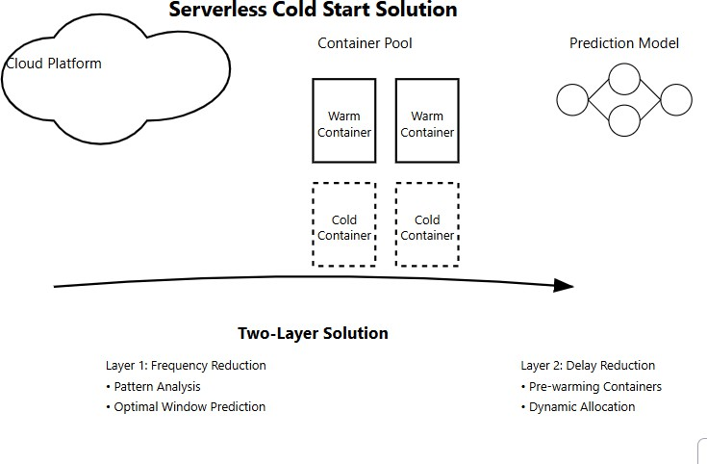

framework seeks to achieve an optimal balance between reducing cold starts and managing resource usage efficiently.

1. **Update Configuration:** Based on the predictions generated by the deep neural network, the idle-container window is dynamically updated within the serverless platform’s configuration settings. This continuous adjustment en- sures that the system maintains the optimal balance between performance ef- ficiency and cost-effectiveness, adapting to changing usage patterns over time.

### Layer 2: Cold Start Delay Reduction

The second layer of the adaptive framework focuses on minimizing delays associated with requests that encounter cold starts, particularly during periods of high demand or simultaneous invocations:

1. **Concurrent Invocation Prediction:** In this step, Long Short-Term Memory (LSTM) models are employed to predict the number of concurrent invocations that a serverless function may experience. By analyzing historical invocation data, the LSTM model anticipates demand spikes and adjusts resource alloca- tion proactively. This predictive capability is vital for ensuring that the system can meet user demand without incurring significant cold start delays.
2. **Pre-warmed Container Allocation:** Based on the predictions of concur- rent invocations, the system allocates pre-warmed containers to facilitate rapid resource availability. By ensuring that enough containers are warm and ready to handle incoming requests, this step significantly reduces cold start times, enhancing user experience and application performance during peak usage.
3. **Dynamic Resource Allocation:** Continuous monitoring of resource usage allows the system to dynamically adjust warm container allocations in real- time. By responding to changing demand patterns, the system enhances re- source efficiency and further reduces the likelihood of cold start delays. This dynamic approach ensures that resources are allocated optimally, preventing over-provisioning or under-utilization.

### Model Formulation and Error Minimization

The proposed adaptive approach incorporates a mathematical model designed to optimize the reward function for effective resource allocation:

* + - * **Reward Function:** To evaluate the effectiveness of resource allocation strate- gies, the reward function is defined as follows [12]:

Reward = *−* Cold + *P*

*N*

In this formula, *Cold* signifies the number of cold starts that occur, *N* represents the total number of invocations within the same period, and *P* is a penalty factor that accounts for memory wastage. By incentivizing the minimization of cold starts while ensuring efficient resource usage, this reward function guides the adaptive framework in optimizing overall performance.

* + - * **Error Minimization and Parameter Update:** The model continuously refines its parameters to minimize errors associated with resource allocation. This refinement process involves updating configurations based on real-time data collected from the serverless environment. The goal is to minimize the balance between resource waste and cost, ensuring that the system operates efficiently while maintaining a high level of responsiveness.

In summary, this adaptive framework provides a robust solution to the cold start challenges commonly faced in serverless computing environments. By optimizing resource usage and minimizing response times, this approach not only enhances the

performance of serverless applications but also ensures a reliable user experience, even during periods of fluctuating demand. The integration of machine learning techniques allows for intelligent decision-making, positioning this framework as a significant advancement in serverless architecture.

### Integration of Explainable AI (XAI) in Adaptive Frame- work

The integration of Explainable AI (XAI) within the proposed adaptive framework enhances transparency and interpretability in resource management decisions for serverless computing. XAI techniques, specifically the Local Interpretable Model- agnostic Explanations (LIME) method, are employed to ensure that machine learning predictions and resource allocation strategies are understandable and trustworthy, particularly for high-stakes, latency-sensitive applications.

1. **Enhancing Model Interpretability with LIME:** To explain the outputs of complex models (such as deep neural networks and LSTMs), LIME is used to create simplified, interpretable models that approximate the behavior of the predictive model on individual predictions. By applying LIME, stakeholders can understand the factors that influence specific resource allocation decisions or pre-warming predictions, such as invocation patterns, memory usage, and function complexity.
2. **Transparent Resource Allocation Decisions:** XAI provides insights into the factors that influence the adaptive framework’s decisions, including the idle-container window and concurrent invocation predictions. By using LIME, the model highlights the most influential features, such as expected invocation frequency and resource consumption, that lead to specific resource management adjustments. This transparency builds trust, especially in scenarios where resource allocation impacts application performance directly.
3. **Improved Trust in High-Demand Scenarios:** In cases of demand surges or concurrent invocation spikes, LIME enables real-time interpretability by providing explanations for why the model recommends specific adjustments. These explanations are particularly valuable in applications requiring strict performance standards, like financial transactions or healthcare monitoring, where understanding model-driven decisions is crucial.
4. **Supporting Continuous Model Refinement:** The insights from LIME can also guide continuous model refinement. By observing the explanations gen-

erated by LIME over time, the adaptive framework can identify patterns that may lead to inaccuracies in resource management. Feedback from LIME ex- planations helps in refining model parameters, thus ensuring that the adaptive framework remains aligned with evolving demand and invocation patterns.

The integration of LIME within the XAI-enabled adaptive framework provides an explainable, trust-building layer that supports the predictive and dynamic resource management processes. This approach strengthens performance optimization and enhances system accountability, user confidence, and overall system reliability.

## Evaluation and Experimental Setup

This section outlines the experimental design and evaluation methodology used to assess the performance of the proposed adaptive model for mitigating cold start latency in serverless environments. It includes a detailed description of the exper- imental setup, the metrics employed for evaluation, and an analysis of the results obtained.

### Experimental Design

The experiments were meticulously conducted using a diverse set of real-world server- less applications deployed across multiple serverless platforms, including Amazon Web Services (AWS) Lambda, Microsoft Azure Functions, and Apache OpenWhisk. This multi-platform approach was adopted to ensure a comprehensive and robust comparison of the adaptive model’s performance across varying cloud environments and configurations.

Each platform was configured with identical parameters, such as memory alloca- tion, execution timeout, and concurrency limits, to guarantee fairness in the compar- ison and isolate the effects of the adaptive model on performance. By standardizing these parameters, we aimed to create a level playing field that accurately reflects the impact of the adaptive techniques without being confounded by platform-specific differences.

|  |  |  |  |  |
| --- | --- | --- | --- | --- |
| **Application** | **Function Count** | **Cold-Start Time (ms)** | **Warm- Start Time (ms)** | **Invocation Count** |
| Email Processing | 5 | 1200 | 200 | 5000 |
| Image Processing | 10 | 1500 | 300 | 7000 |
| Data Analysis | 8 | 1300 | 250 | 4500 |
| Video Transcoding | 6 | 1600 | 350 | 3000 |

Table 1.2: Serverless Applications Used for Evaluation

The dataset utilized for evaluation comprised four distinct serverless applications, each characterized by unique computational requirements and resource utilization patterns. Table 1.2 presents a summary of these applications, highlighting the num- ber of functions, along with their corresponding cold-start and warm-start execution times. This detailed logging enabled comprehensive data collection, which facilitated an in-depth performance analysis and comparison between the adaptive model and traditional cold-start mitigation strategies.

### Performance Metrics

To evaluate the effectiveness of the adaptive model, we analyzed several key perfor- mance metrics that directly reflect the system’s performance in terms of responsive- ness and efficiency:

* + - * **Response Time:** This metric measures the average time taken to execute each function, expressed in milliseconds. A reduction in response time is indicative of improved efficiency in request processing, reflecting how quickly the system can respond to user invocations.
      * **Cold-Start Delay:** This metric refers to the additional time incurred when a function is invoked after a period of inactivity. It is calculated as the differ- ence between cold-start and warm-start execution times. Monitoring cold-start delay provides insights into the model’s effectiveness in reducing initialization overhead, which is critical for latency-sensitive applications.
      * **Frequency of Cold Starts:** This quantifies the number of cold start occur- rences within a specific timeframe. A lower frequency of cold starts indicates

better container management and contributes to enhancing overall system per- formance and user experience. This metric is particularly important for as- sessing the economic efficiency of the adaptive approach, as it correlates with reduced resource overhead.

### Results and Analysis

The evaluation results, summarized in Figures 1.4 and 1.5, illustrate the significant performance improvements achieved by the adaptive model compared to traditional cold-start mitigation techniques:

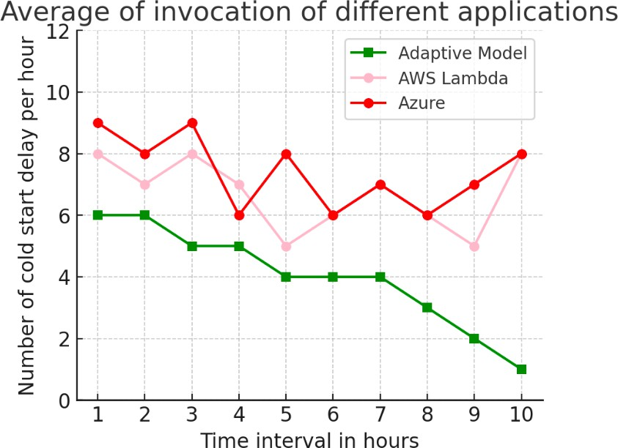

Figure 1.4: Cold Start Delay Reduction

* + - * **Response Time Analysis:** As depicted in Figure 1.5, the adaptive model demonstrated a remarkable reduction in average response times across all ap- plications, achieving an approximately 30% decrease. This improvement can be attributed to the model’s predictive capability, which enables it to pre- warm containers based on historical invocation patterns. By anticipating when functions are likely to be invoked, the model minimizes cold-start initialization time, thereby enhancing overall system responsiveness.
      * **Cold-Start Delay Reduction:** Figure 1.4 illustrates that the adaptive model successfully decreased cold-start delays by an average of 40% across the eval- uated applications. This significant reduction results from the adaptive man- agement of containers, which anticipates periods of inactivity and adjusts pre-

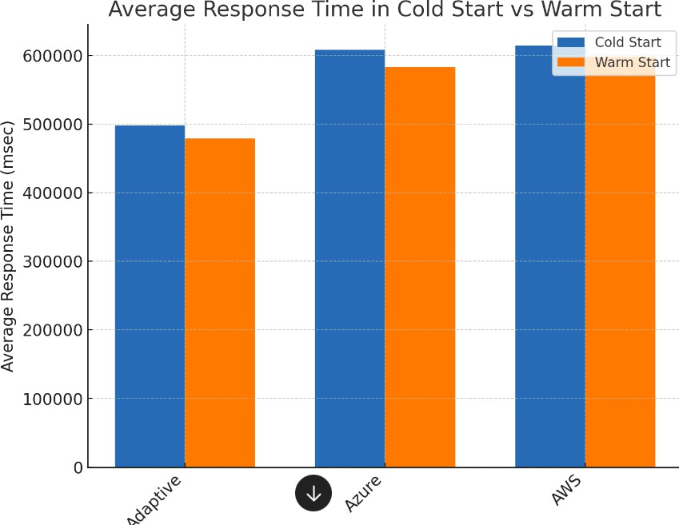

Figure 1.5: Average Response Time Analysis

warmed container allocations accordingly. Such proactive management min- imizes the cold-start impact on latency-sensitive applications, ensuring that users experience reduced wait times.

* + - * + **Frequency of Cold Starts:** The results indicate that the adaptive model effectively reduced the frequency of cold starts by up to 50%. This reduction implies greater efficiency in resource utilization and an improved user experi- ence, as fewer instances of cold starts lead to smoother operation. Additionally, this decrease in cold starts can yield potential cost savings for service providers, as it reduces the number of containers that need to be allocated and maintained, thereby minimizing resource overhead.

In conclusion, the results indicate that the proposed adaptive model not only enhances performance by reducing response times and cold-start delays but also contributes to more efficient resource utilization, which is crucial for the scalability and economic viability of serverless architectures. These findings suggest that inte- grating adaptive mechanisms based on machine learning can significantly improve the user experience in serverless environments, making them more responsive and cost-effective.

*1.7. DISCUSSION* 21

## Discussion

In this section, we discuss the implications of our findings, interpreting the results of our evaluation and exploring how the proposed adaptive model can be applied in real-world scenarios.

### Interpretation of Results

The evaluation results demonstrate a clear advantage of the proposed adaptive model over traditional cold start mitigation techniques across several key performance met- rics, notably response time, cold-start delay, and frequency of cold starts. By em- ploying machine learning algorithms to analyze historical invocation data, our model effectively predicts invocation patterns, enabling it to dynamically adjust the readi- ness of serverless containers in anticipation of incoming requests.

This predictive capability is critical in reducing cold start latency. Traditional methods often rely on static pre-warming strategies, which may lead to either over- provisioning or under-provisioning of resources. In contrast, our adaptive model optimizes container availability by dynamically managing their states, ensuring that functions are ready to respond to requests with minimal delay. This adaptability not only enhances the system’s overall efficiency but also results in improved user satisfaction due to faster response times.

Moreover, the reduction in cold start frequency is particularly noteworthy. A lower frequency of cold starts implies that fewer containers need to be unnecessarily warmed up, leading to significant operational cost savings. This optimization of resource allocation is especially beneficial in serverless architectures, where billing is often based on resource utilization. By minimizing the need for container warming, the adaptive model aligns well with the economic incentives of serverless computing, allowing organizations to achieve better performance without incurring excessive costs.

### Implications for Real-World Applications

The implications of the adaptive model’s ability to minimize cold start delays are pro- found, especially for latency-sensitive applications that demand high responsiveness and reliability. In fields such as real-time data processing for Internet of Things (IoT) systems and financial transactions, even minor delays can have significant repercus- sions. For instance, in financial applications, delays in transaction processing can lead to financial losses or affect user trust. By implementing our adaptive model,

organizations can ensure that their applications maintain low-latency performance even during peak usage periods.

Furthermore, the scalability of the adaptive model makes it particularly suitable for diverse use cases across various industries [2,](#_bookmark4) [4]. As businesses increasingly mi- grate to cloud-native architectures, maintaining high performance during fluctuating demand becomes crucial. The model’s proactive management of container states based on anticipated usage patterns allows serverless platforms to effectively handle dynamic workloads without sacrificing performance. This capability is especially rel- evant in scenarios characterized by unpredictable spikes in traffic, where traditional cold start mitigation techniques may struggle to keep up.

Additionally, the adaptive model can be integrated with other performance op- timization strategies, such as load balancing and auto-scaling, to further enhance application responsiveness. By collaborating with these mechanisms, the model can create a holistic approach to resource management that maximizes efficiency and minimizes latency across serverless environments.

In conclusion, the adaptive model presented in this study not only addresses the critical issue of cold start latency in serverless computing but also opens up new avenues for enhancing application performance in real-world scenarios. By leverag- ing machine learning to optimize container readiness, organizations can improve user experiences, reduce operational costs, and maintain high performance in an increas- ingly cloud-centric landscape. The findings of this study provide a compelling case for the adoption of adaptive strategies in the design and implementation of serverless applications, paving the way for more responsive and efficient cloud services.

## Conclusion

This study presents an adaptive model designed to address the cold start problem in serverless computing environments. The model uses machine learning to ana- lyze historical function invocation patterns, enabling it to predict inactivity periods and dynamically manage container states. This approach enhances key performance metrics, including response time, cold start delay, and overall operational efficiency. Experimental results demonstrate the model’s effectiveness, reducing cold start frequency by up to 50% and cold start delays by an average of 40%. These im- provements highlight the model’s advantage over conventional cold start mitigation strategies, which typically rely on static pre-warming or resource allocation meth- ods that fail to adapt to real-time demand fluctuations. By dynamically adjusting container readiness, the model not only improves application responsiveness but also optimizes resource utilization, contributing to cost savings in serverless architectures.

*1.9. FUTURE DIRECTIONS* 23

Despite these successes, there are limitations to the adaptive model. One signifi- cant challenge is the model’s reliance on comprehensive historical data for accurate predictions. In situations where historical data is sparse or not representative of future usage patterns, the predictive accuracy may decrease, leading to suboptimal container management. Therefore, careful data collection and preprocessing are crit- ical to ensuring effective model performance.

Additionally, the model may require fine-tuning to maintain its performance across different serverless platforms. Variations in architecture, resource allocation policies, and workload characteristics can impact the model’s effectiveness. Future re- search should focus on strategies for automated tuning and improving cross-platform adaptability to increase robustness.

Further improvements can be made by incorporating security considerations into the model, especially as security becomes a growing concern in cloud computing environments. Ensuring data privacy and integrity while optimizing performance will be vital for widespread adoption.

Moreover, adapting the model to environments where cold start issues are partic- ularly severe, such as highly latency-sensitive applications, could expand its applica- bility. This could involve adding context-aware features to capture real-time traffic patterns and user behaviors, further enhancing prediction accuracy and responsive- ness.

In conclusion, this adaptive model provides a promising solution to the cold start problem in serverless computing. By leveraging machine learning to optimize container readiness, the model not only boosts application performance but also offers a scalable approach to resource management, contributing to more efficient and reliable serverless architectures.

## Future Directions

### Advanced Model Optimizations

Future research should focus on refining the predictive algorithms to further improve the accuracy of cold start predictions. Incorporating additional data sources, such as user activity trends or environmental conditions, could enhance the model’s ability to anticipate demand surges. Machine learning approaches such as ensemble learning or reinforcement learning could be explored to create more adaptive and responsive container management strategies that can self-tune in real-time.

### Broader Application Scenarios

Beyond traditional serverless environments, the proposed model has potential appli- cations in edge computing and IoT, where cold start latency can have a significant impact on user experience. By optimizing container readiness at the network edge, this model could support faster responses for latency-sensitive services, such as au- tonomous vehicle coordination or smart city infrastructure. Additionally, the model could be adapted to manage resources in hybrid cloud setups, where workload distri- bution between cloud and edge environments requires seamless coordination to meet application.

# Bibliography

1. Siddharth Agarwal, Maria A. Rodriguez, and Rajkumar Buyya. A reinforcement learning approach to reduce serverless function cold start frequency, 2021. [Link.](http://clouds.cis.unimelb.edu.au/papers/RL-ServerlessFunction-CCGrid2021.pdf)
2. Mahfooz Alam, Suhel Mustajab, Mohammad Shahid, and Faisal Ahmad. Cloud computing: Architecture, vision, challenges, opportunities, and emerging trends. In *2023 International Conference on Computing, Communication, and Intelli- gent Systems (ICCCIS)*, pages 829–834, 2023. [Link.](https://ieeexplore.ieee.org/document/9687209)
3. Ta Phuong Bac, Minh Ngoc Tran, and YoungHan Kim. Serverless computing approach for deploying machine learning applications in edge layer, 2022. [Link.](https://ieeexplore.ieee.org/document/9687209)
4. Dev Baloni, Chandradeep Bhatt, Satender Kumar, Pritesh Patel, and Teekam Singh. The evolution of virtualization and cloud computing in the modern computer era, 2023. [Link.](https://ieeexplore.ieee.org/document/10421611)
5. Hassan B. Hassan, Saman A. Barakat, and Qusay I. Sarhan. Survey on serverless computing, 2021. [Link.](https://ieeexplore.ieee.org/document/9687209)
6. Thu Yein Htet, Thanda Shwe, Israel Mendonca, and Masayoshi Aritsugi. Pre- warming: Alleviating cold start occurrences on cloud-based serverless platforms, 2024. [Link.](https://ieeexplore.ieee.org/document/10629113?denied)
7. Xuanzhe Liu, Jinfeng Wen, Zhenpeng Chen, Ding Li, Junkai Chen, Yi Liu, Haoyu Wang, and Xin Jin. Faaslight: General application-level cold-start la- tency optimization for function-as-a-service in serverless computing, 2023. [Link.](https://dl.acm.org/doi/10.1145/3585007)
8. Garrett McGrath and Paul R. Brenner. Serverless computing: Design, imple- mentation, and performance, 2017. [Link.](https://ieeexplore.ieee.org/document/7979855)
9. Manish Pandey and Young-Woo Kwon. Funcmem: Reducing cold start latency in serverless computing through memory prediction and adaptive task execution, 2024. [Link.](https://dl.acm.org/doi/10.1145/3605098.3636033)

25

26 *BIBLIOGRAPHY*

1. Khondokar Solaiman and Muhammad Abdullah Adnan. Wlec: A not so cold architecture to mitigate cold start problem in serverless computing, 2020. [Link.](https://ieeexplore.ieee.org/abstract/document/9096489)
2. Benneth Uzoma and Bonaventure Okhuoya. A research on cloud computing, 12 2022. [Link.](https://www.researchgate.net/publication/366320853_A_RESEARCH_ON_CLOUD_COMPUTING)
3. Parichehr Vahidinia, Bahar Farahani, and Fereidoon Shams Aliee. Mitigating cold start problem in serverless computing: A reinforcement learning approach. *IEEE Internet of Things Journal*, 10(5):3917–3927, 2023. [Link.](https://ieeexplore.ieee.org/document/9749611)
4. Joe Weinman. The future of cloud computing. In *2011 IEEE Technology Time Machine Symposium on Technologies Beyond 2020*, pages 1–2, 2011. [Link.](https://ieeexplore.ieee.org/document/6005157?denied)
5. Amelie Chi Zhou, Rongzheng Huang, Zhoubin Ke, Yusen Li, Yi Wang, and Rui Mao. Tackling cold start in serverless computing with multi-level container reuse, 2024. [Link.](https://scholars.hkbu.edu.hk/en/publications/tackling-cold-start-in-serverless-computing-with-multi-level-cont)
6. Yu Chen Zhou, Xin Peng Liu, Xi Ning Wang, Liang Xue, Xiao Xing Liang, and Shuang Liang. Business process centric platform-as-a-service model and technologies for cloud enabled industry solutions, 2010. [Link.](https://ieeexplore.ieee.org/document/9687209)